# TITLE: AUTONOMOUS VEHICLE AND ROBOTICS

## Objective:

* To design and implement an intelligent autonomous vehicle system capable of navigating in real-time using computer vision, sensor data, and machine learning algorithms. The system can also be adapted for robotic platforms in various environments (indoor and outdoor).

## Overview:

* Autonomous vehicles and robots rely on sensors, cameras, and algorithms to perceive their environment and make decisions. This project integrates key components such as path planning, obstacle detection, lane detection, and object recognition using Python and ROS (Robot Operating System).

## Implementation:

### 1. Hardware Components:

* Raspberry Pi / NVIDIA Jetson Nano
* Ultrasonic Sensors / LIDAR
* Camera (e.g., Pi Camera)
* Motor Driver & Chassis
* GPS Module (optional)

### 2. Software Stack:

* Python
* OpenCV for Computer Vision
* TensorFlow or Py Torch for ML models
* ROS for robotics middleware (optional)
* Arduino for motor and sensor control

### 3. Key Functional Modules:

##### Lane Detection (Computer Vision):

* Use OpenCV to detect lanes in real-time video feed.

##### Obstacle Detection (Sensor Fusion):

* Integrate ultrasonic/LIDAR data to avoid collisions.

##### Object Recognition (ML/DL):

* Train a lightweight CNN to detect traffic signs or pedestrians.

##### Path Planning & Navigation:

* A* or Dijkstra’s algorithm for planning
* PID controller for motion control

## Challenges and Solutions:

CHALLENGES:

* Real-time processing
* Noisy sensor data
* Limited hardware resources
* Complex environments

SOLUTIONS:

* Use lightweight models and optimize code with multithreading or CUDA
* Apply Kalman filter or sensor fusion algorithms
* Use jetson nano or cloud-based inference if allowed
* Implement SLAM which stands for Simultaneous localization and mapping

## Outcomes:

1. A working prototype of an autonomous robotic car.
2. Capable of navigating a predefined track with real-time obstacle avoidance and lane following.
3. Modular codebase for adaptation to other robotic projects.
4. Data collected for further improvement and ML model training.

# LANE DETECTION:

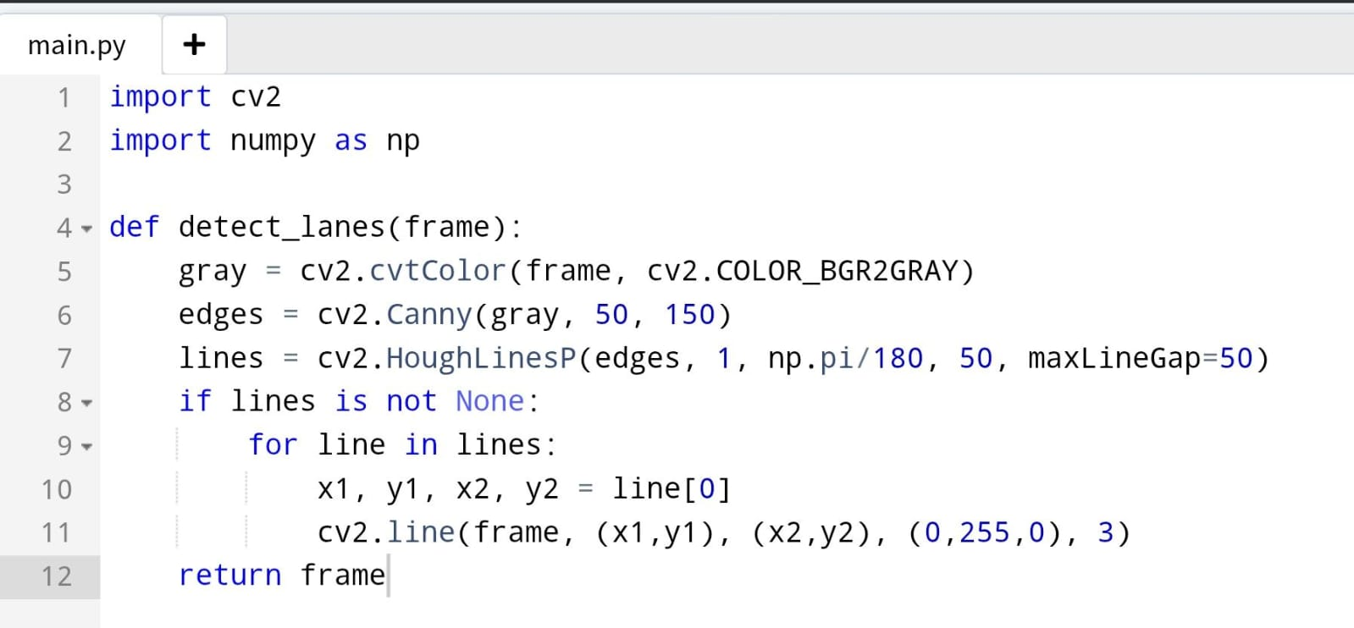

# OBSTACLE DETECTION:

